Chapter 2: Basic Chemistry
- Define matter.
    - Matter is anything that has mass and occupies space
- What states does matter exist in?
- Solid
- Liquid
- Gas
- All matter (both living and non-living) is composed of 92 naturally-occurring elements.
- Define an element.
    - An element is a substance that cannot be broken down into substances with different properties; composed of one type of atom
- What are the six elements that make up 95% of the body weight of organisms?
- Carbon
- Hydrogen
- Nitrogen
- Oxygen
- Phosphorus
- Sulfur (CHNOPS)
- Elements consist of tiny particles called atoms.
- Define an atom.
    - An atom is the smallest unit of an element that displays the properties of an element.
- What are the subatomic particles its composed of?
- Protons
- Neutrons
- Electrons
- What subatomic particles are found in the central nucleus?
    - Protons – positively charged, 1 amu (atomic mass unit)
    - Neutrons – no charge, 1 amu
- Where subatomic particles are found orbiting clouds around the nucleus? (electron shells)
    - Electrons – negatively charged, very low mass-negligible in calculations (0 amu)
Electrons and energy:
- In an electrically neutral atom, the positively charged protons are balanced by the negatively charged electrons (remember that neutrons are electrically neutral).
- Since electrons are found outside the nucleus and occupy orbitals around the nucleus, many scientists have tried to create models to show the exact location of the electrons.
- The Bohr model (named after physicist Niels Bohr) is a helpful way to visualize electron location in an element.
- According to the Bohr model, electrons occupy orbitals within various energy levels (or electron shells) near or distant from the nucleus of the atom. The farther the orbital from the nucleus, the higher the energy level.
- When atoms absorb energy during photosynthesis, electrons are boosted to higher energy levels. When the electrons return to their original energy level, the released energy is converted into chemical energy. This chemical energy supports all life on Earth.
- The innermost shell of an atom is complete with 2 electrons; all other shells are complete with 8 electrons. This is called the octet rule.
- The outermost electron shell is called the valence shell and determines the atom’s chemical properties; atoms will give up, accept, or share electrons in order to have 8 electrons in its valence shell.

- What is the atomic number equal to?
    - The atomic number is equal to the number of protons in each atom of an element.
- What is the mass number?
    - The mass number of an atom is equal to the number of protons and neutrons in an atom’s nucleus
- Groups are the vertical columns in the table and periods are the horizontal rows.
- Define isotopes.
    - Isotopes are atoms of the same element that differ in the number of neutrons (and therefore different atomic masses)
- A carbon atom with 8 rather than 6 neutrons is unstable; it releases energy and subatomic particles and is thus a radioactive isotope.
- Because the chemical behavior of a radioactive isotope is the same as a stable isotope of a particular element, low levels of the radioactive isotope (e.g., radioactive iodine or glucose) allow researchers to trace the location and activity of the element in living tissues; these isotopes are called tracers.
- Define a molecule.
    - A molecule is two or more elements bonded together.
- Define a compound.
    - A compound is a molecule containing at least two different elements bonded together.
Chemical Bonding
- Bonds that exist between atoms in molecules contain energy.
- Bonds between atoms are caused by the interactions between electrons in outermost energy shells.
- Define a chemical reaction.
    - A chemical reaction is the process of bond formation.
Types of bonding: Ionic bonding
- Define an ion.
    - An ion is an atom that has lost or gained an electron.
- How does an ionic bond form?
    - An ionic bond forms when electrons are transferred from one atom to another atom and the oppositely charged ions are attracted to one another.
- Salts are solid substances that usually separate and exist as individual ions in water.

Covalent Bonds
- What do covalent bonds result from?
    - Covalent bonds result when two atoms share electrons, so each atom has an octet of electrons in the outer shell. (in the case of hydrogen, the outer energy shell is complete when it contains 2 electrons)
- In a nonpolar covalent bond, electrons are shared equally between atoms.
- In a polar covalent bond, electrons are shared unequally.
- Define electronegativity.
    - Electronegativity is the ability of an atom to attract electrons towards itself in a chemical bond.
The Chemistry of Water
- Life started in water.
- The earth is about 72% covered in water.
- Living organisms are 70% water.
- All living organisms spend their early life stages in water or moist environments.
- Why is water important?
- It is liquid at relatively low temperatures.
- It is a great filter at UV radiation.
- Water is a polar molecule.
    - The shape of a water molecule and its polarity make hydrogen bonding possible.
- A hydrogen bond is a weak attraction between a slightly positive hydrogen atom and a slightly negative atom.
    - A single hydrogen bond is easily broken while multiple hydrogen bonds are collectively quite strong.
    - Help to maintain the proper structure and function of complex molecules such as proteins and DNA.
    - Hydrogen bonds reason for many of water’s properties.
    - Because of electrical charges and polarity, it dissolves other charged particles.
- What are properties of water?
- Water has a high heat capacity
    - The temperature of liquid water rises and falls more slowly than that of most other liquids.
    - A calorie is the amount of heat energy required to raise the temperature of one gram of water 1°C.
    - Because the hydrogen bonds between water molecules hold more heat, water temperature falls more slowly than other liquids; this protects organisms from rapid temperature changes and helps them maintain homeostatic temperature.

  - Water has a high heat of vaporization.
    - Hydrogen bonds must be broken down to evaporate water.
    - Bodies of organisms cool when their heat is used to evaporate water.
  - Water is a good solvent.
    - Water is a good solvent because of its polarity.
    - Hydrophilic molecules (polar, ionized) dissolve in water
    - Hydrophobic molecules (non-polar, non-ionized) do not dissolve in water.
  - Water molecules are cohesive and adhesive
    - Cohesion is the ability of water molecules to cling to each other due to hydrogen bonding.
          - Water flows freely
          - Surface tension. (high surface tension makes it difficult to break through at its surface)
    - Adhesion is the ability of water molecule to cling to other polar surfaces.
          - Adhesion is due to water’s polarity
          - Capillary action
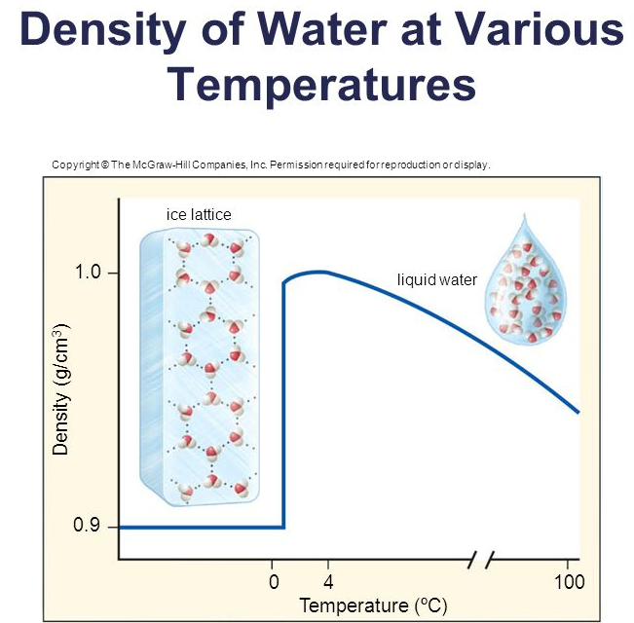
    - Cohesion and adhesion account for water transport in plants as well as transport in blood vessels
  - Ice is less dense than liquid water
    - At temperatures below 4 °C, hydrogen bonds between water molecules become more rigid but more open, causing expansion.
    - Water expands as it reaches 0°C and freezes.
    - Ice floats on liquid water.
          - Acts as an insulator on top of a frozen body of water to prevent deep water from freezing.

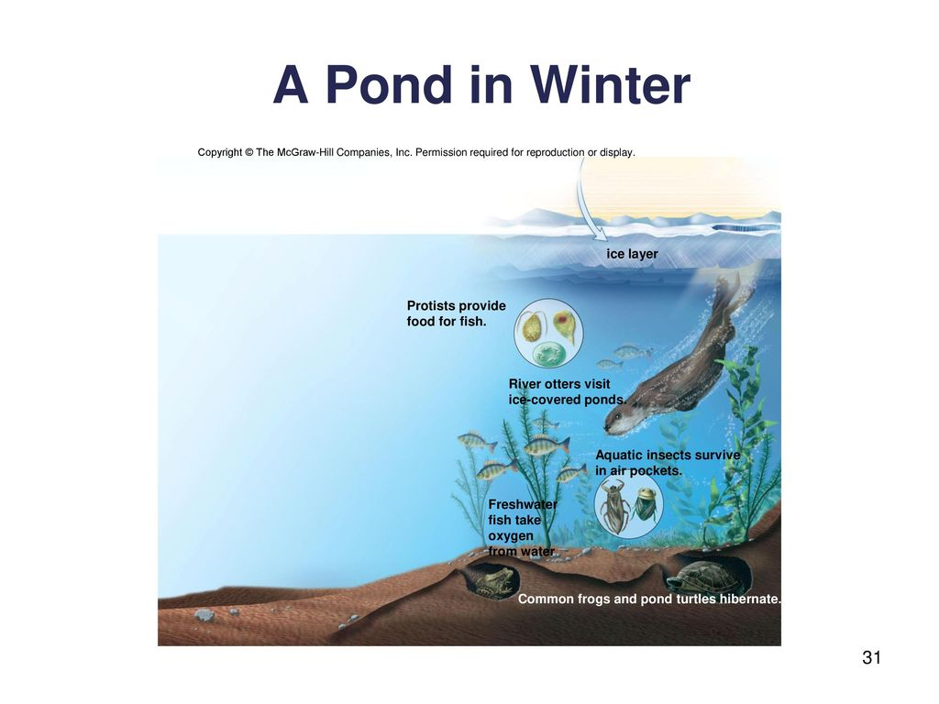
Acids and Bases
- Define pH.
    - pH is a measure of hydrogen ion concentration in a solution.
- When water ionizes or dissociates, it releases an equal number of hydrogen (H+) ions and hydroxide (OH-) ions.
- Define acids.
    - Acids are substances that dissociate in water, releasing hydrogen ions.
- Define bases.
    - Bases are substances that either take up hydrogen ions (H+) or release hydroxide ions. (OH-)
The pH Scale
- What is the pH scale used to indicate?
    - The pH scale is used to indicate the acidity or basicity (alkalinity) of a solution
- Values range from 0-14
    - 0 to <7= acidic
    - 7=neutral
    - >7 to 14=basic (or alkaline)
- Logarithm scale
    - Each unit change in pH represents a 10-fold change in H+ concentration
    - pH of 4 is 10x as acidic as pH of 5.
    - pH of 10 is 100x more basic than pH of 8.
- The normal pH of blood is 7.4.
Buffers and pH
- Define a buffer.
    - A buffer is a chemical or a combination of chemicals that keeps pH within normal limits.
- Health of organisms requires maintaining the pH of body fluids within narrow limits.
    - If blood pH drops below 7.0, acidosis results.
    - If blood pH rises above 7.0, alkalosis results.
    - Both are life-threatening situations.
- Carbonic acid helps keep blood pH within normal limits.
- Body has built-in mechanisms to prevent pH changes.
- H₂CO₃ is a buffer that reduces basicity.
- NaHCO₃ is a buffer that reduces acidity.

